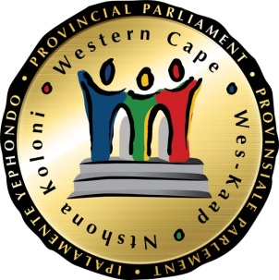
PETITIONS COMMITTEE

Fact finding oversight visit to Mossel Bay
19 – 21 July 2022

(As at 08 July 2022)

Delegation:
Dugmore, Cameron D
Mackenzie, Ricardo Denver
Makamba-Botya, N
Plato, Daniel
Sayed, Muhammad Khalid

Procedural Officer: Wasiema Hassen-Moosa (084-223-1789)
Senior Coordinator: Ben Daza (021 487 1679)

Petitions Committee

DATE | TIME | ACTIVITY | VENUE AND ADDRESS
Tuesday, 19 July 2022 | 09h30 – 11h00 | A walk-about in Power Town and Sonskynvallei townships in Mossel Bay | 84 Power Town and Sonskynvallei in Klein Brakrivier, Mossel Bay
Tuesday, 19 July 2022 | 11h30 – 13h00 | A walk-about in Groot Brakrivier in Mossel Bay | Groot Brakrivier in Mossel Bay
Tuesday, 19 July 2022 | 13h30 – 14h00 | Drive from Groot Brakrivier to Mossel Bay

DATE | TIME | ACTIVITY | VENUE AND ADDRESS
Wednesday, 20 July 2022 | 13h00 - 14h45 | Meeting with the petitioners of Power Town community in Klein Brakrivier, the Department of Human Settlements and the Mossel Bay Municipality | Mossel Bay Municipality Office, 101 Marsh Street, Mossel Bay
Wednesday, 20 July 2022 | 14h45 – 15h00 | BREAK
Wednesday, 20 July 2022 | 15h00 – 16h45 | Meeting with the petitioners of Groot Brakrivier community, the Commission on Restitution of Land Rights in the Western Cape and the Mossel Bay Municipality | Mossel Bay Municipality Office, 101 Marsh Street, Mossel Bay
Wednesday, 20 July 2022 | 17h00 | Depart to Hotel

Chairperson: Mr D Plato
Procedural Officer: Ms W Hassen-Moosa
Time-keeper: Ms MA Burgess
*Please note that this is a Draft Framework Programme the chairperson may alter as per the committee’s needs

