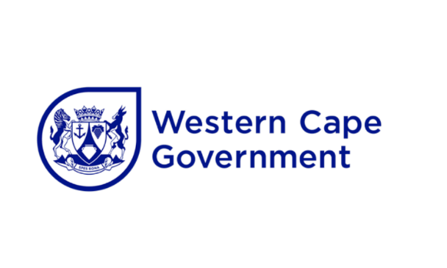
SUBMISSION: PROVINCIAL PARLIAMENTARY WRITTEN QUESTION 12: TB BURDEN
FRIDAY, 11 AUGUST 2023

- DIRECTOR: COMMUNICATIONS
The attached for you the Head of Department and the Minister’s approval/ signature.
COMMENTS:
Inputs sourced from IM and SPC.
DIRECTOR: DATE:
______________________________________________________________
- SUPERINTENDENT - GENERAL
COMMENTS:
…………………………………………………………………………………………

HEAD OF HEALTH AND WELLNESS DATE:

______________________________________________________________
- COMMENTS:
……………………………………………………………………………..…………

MINISTER OF HEALTH & WELLNESS: ……………………….…DATE:

……………………………

Friday, 11 August 2023] 63
No 18 - 2023] FIFTH SESSION, SIXTH PARLIAMENT

PARLIAMENT OF THE PROVINCE OF THE WESTERN CAPE

QUESTION PAPER

WRITTEN REPLY

FRIDAY, 11 AUGUST 2023
12. Mr G Pretorius to ask Dr N Mbombo, Minister of Health and Wellness:
(a) How many patients has her Department treated for tuberculosis in (i) 2020, (ii) 2021, (iii) 2022 and (iv) 2023 to date, (b) to what extent does tuberculosis continue to threaten public health in the province and (c) what challenges does her Department face in responding to tuberculosis in the province?
(475)
RESPONSE
- Data:
 | 2020 | 2021 | 2022 | 2023
Element
DS-TB treatment start 5 years and older | 12941 | 22204 | 27376 | 15391
DS-TB treatment start under 5 years | 1332 | 3005 | 3362 | 1452
TB client 5 years and older start on treatment | 6065
TB client under 5 years start on treatment | 459
Grand Total | 20797 | 25209 | 30738 | 16843

- TB continues to be a public health threat in the province. The December 2021 cascade (the most recent cascade with complete treatment outcomes for all clients in the cohort) shows a 69% Drug Sensitive (DS) treatment success, 50% Rifampicin resistant (RR) TB treatment success, 3% death rate and 26% loss to follow up rate. The province has implemented a multi-pronged TB Recovery strategy, aiming to increase TB screening and early diagnosis with new TB diagnostic tools such as urine LAM (lipoarabinomannan), and Targeted Universal TB Testing for individuals at high risk of getting TB. The strategy also aims to increase the number of clients that successfully start treatment – by SMSing of TB test results to clients and providing support for newly diagnosed clients via TB telehealth. Access to TB preventive treatment will be expanded to all close contacts of clients with TB and community- based contact tracing and TB testing by community health workers has been successfully piloted. A public facing TB dashboard is available to raise public awareness of TB in the province. Additionally, TB services have been broadened and transitioned from siloed to comprehensive services and are available across PHC platforms including CHC, CDC’s and mobile sites, supported by partners and NPOs. The province is supporting the transition to comprehensive services and strengthening services delivery with various policies such as the MECC (make every contact count), as well as the COPC (community orientated primary care) policies.

© Despite the efforts towards eradicating TB, effects are affected by multiple social drivers, impacted on clients’ ability to access diagnostics and treatment as well as social drivers impacting on treatment adherence:
- Mental health
- Substance and alcohol misuse
- Housing and sanitation barriers including overcrowding and poor ventilation
- Lack of dedicated treatment facilities for MDR clients that are therapeutically destitute and those that need palliative care
- Stigma and discrimination still prevent many people from taking treatment and completing treatment

Working in close collaboration with the Provincial Council on AIDS & TB (PCAT), the province is exploring Whole of Society (WOSA) and Whole of Government (WOGA) approaches to addressing the TB epidemic.

MINISTER OF HEALTH AND WELLNESS
DATE

