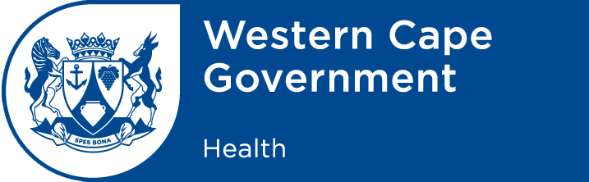

SUBMISSION: PROVINCIAL PARLIAMENTARY QUESTION: 1 (Alcohol related trauma)

WRITTEN REPLY

THURSDAY, 11 SEPTEMBER 2020

- DIRECTOR: COMMUNICATIONS
The attached for you the Head of Department and the Minister’s approval/ signature.

COMMENTS:
…………………………………………………………………………………………………………….
…………………………………………………………………………………………………………….
DIRECTOR: DATE:
___________________________________________________________________________________

- SUPERINTENDENT - GENERAL
COMMENTS:
…………………………………………………………………………………………………………….
…………………………………………………………………………………………………………….
HEAD OF HEALTH: ……………….………………………….. DATE: ……….……..……………….
___________________________________________________________________________________

- COMMENTS:
…………………………………………………………………………………………………………….
…………………………………………………………………………………………………………….
MINISTER OF HEALTH:………………………….……………….DATE: ……….…..………………….
___________________________________________________________________________________

NB: Inputs received from Sentinal Report; Dr Kariem; Karen Ching and Marika Champion .

PARLIAMENT OF THE PROVINCE OF THE WESTERN CAPE

WRITTEN REPLY

THURSDAY, 11 SEPTEMBER 2020

- Mr G Brinkhuis to ask Dr N Mbombo, Minister of Health:
With reference to the lifting of the ban on alcohol:

- Whether she can provide the number of alcohol-related trauma cases at all provincial hospitals; if so, what was the nature of the cases;
- whether the provincial hospitals are equipped to deal with the additional trauma cases and COVID-19 related admittance to hospital; if not, why not; if so, what are the relevant details?
(471)

RESPONSE

- While the link between alcohol and trauma cases is well established, as reflected in the statistics from the Sentinel Report; which shows an increase in the number of trauma cases when the alcohol ban was lifted. However not every trauma case presenting at a health facility can be attributed to alcohol use. To confirm that alcohol was involved requires testing for alcohol levels, at the scene where the trauma took place and this is not always possible for every case.

- During the two months prior to the lockdown, these facilities collectively saw 5 277 trauma cases. Prior to lockdown there is a consistent trend of weekend spikes of 140-160 trauma cases across the 5 facilities sampled. The average (median) across the period was 89 daily trauma cases.

During lockdown and alcohol ban 2 704 trauma cases were seen - reducing the number of cases to approximately 60-80 trauma cases at the weekend spikes. The average (median) across the period reduced to 46 daily trauma cases.

- One month prior to Level 3, 1 638 trauma cases presented with the average (median) over the period was 50 daily trauma cases. However, one month after Level 3, 2 439 trauma cases were attended to with the average (median) during the period increased to 81 trauma cases per day.
- The four weeks prior to the reinstatement of the alcohol ban 2 311 trauma cases presented with an average (median) daily trauma cases were 80 with the weekend spikes reaching as high as 143 trauma cases.
Four weeks after the reinstatement of the alcohol ban the average (median) 1 586 trauma cases attended health facilities and there was a 30% reduction in daily trauma cases (56 daily trauma cases).

- Though we have seen increases in trauma cases since the alcohol ban was lifted the health platform has sufficient available capacity to admit both COVID-19 and non-COVID cases. The bed utilisation across the province has remained below 75% over the last few weeks.

MINISTER OF HEALTH
DATE:

